Add libraries

Ⅰ.Install Arduino libraries

As you become familiar with the Arduino software and the built-in features, you may want to extend the Arduino functionality with other libraries.

Ⅱ.What are libraries?

For example, the built-in LiquidCrystal library lets you easily talk to character LCD displays. There are hundreds of additional libraries available for download on the Internet. The built-in libraries and some of these additional libraries are listed in Resources, and to use the additional libraries, you need to install them.

Ⅲ.How to install Libraries

1.The easiest way to add a library
①.Open Arduino IDE, click “sketch”→ Click “Include Library”→ click “Add ZIP Library”.
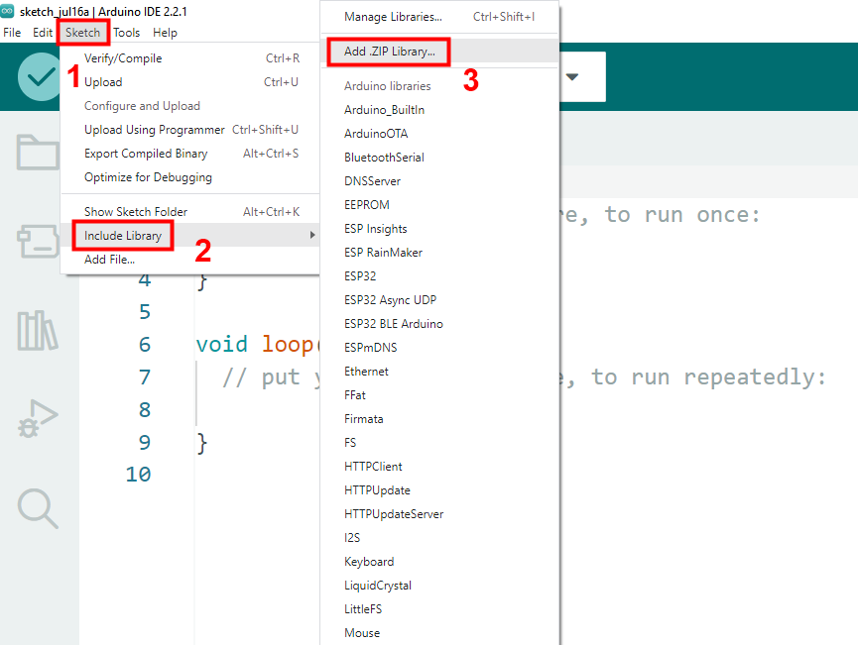
②. Select the library compressed file in the folder "English\Arduino(Experienced Learner)\3.Librarise", then click "Open". (The libraries shown in the image below are for demonstration purposes only; please add the libraries provided in the textbook.)

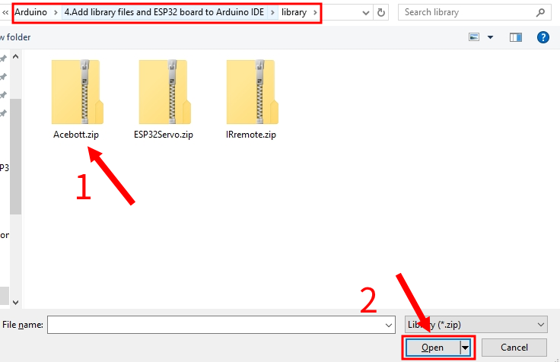

③.Repeat the same steps to add all the compressed library files.

④.Check whether the library file is added successfully.
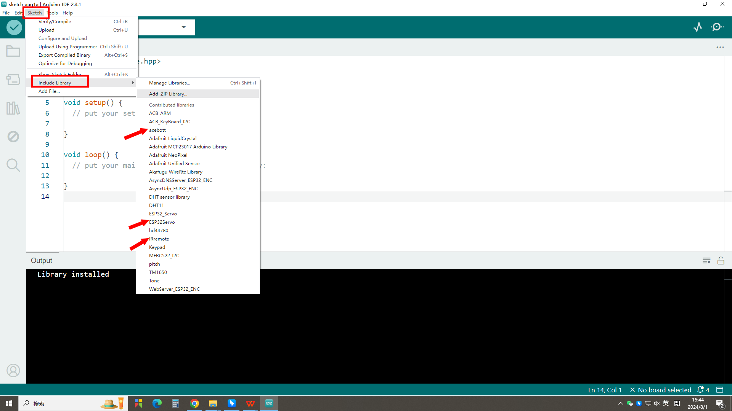

2.Use a library manager
To install a new library in the Arduino IDE, you can use the manager libraries.
Open the Arduino IDE and click"Tools>Manage Libraries".
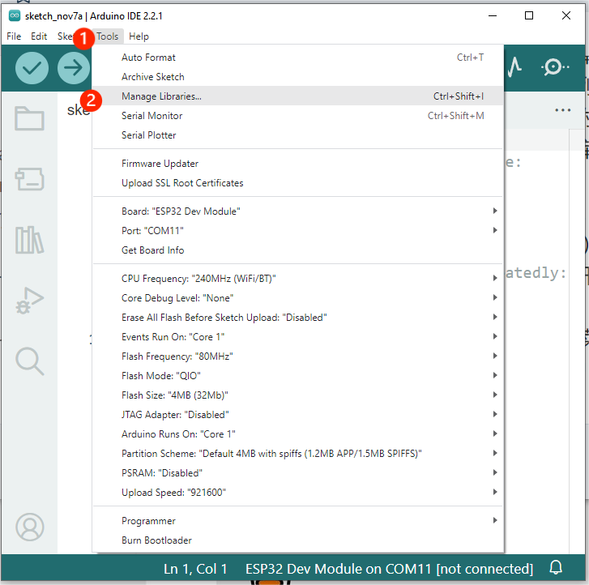
Find the library you want in the search bar and click Install. For example, if you need the library Adafruit NeoPixel, you can search for it in the search bar, find it, and click Install.
